Sample Email for Employees
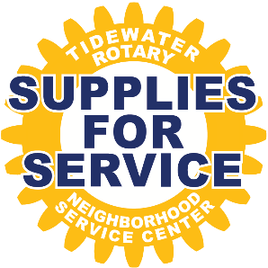
Subject Line – Supplies for Service drive
XXX is joining with Tidewater Rotary and supporting their Supplies for Service drive benefiting the Neighborhood Service Center.
Founded in 1969, the Neighborhood Service Center has been committed to improving the quality of life, both socially and economically, by serving low-income residents of Talbot County.
Since the beginning of the pandemic, they have seen the demand for their resources dramatically increase.
While food donations have been steady, often forgotten are the needs for basic household items such as paper towels, cleaning supplies and toiletries. These items are often harder to afford are not covered by food stamps.
To assure their clients are being served, they have greatly expanded their mobile efforts through their Mobile Food Pantry. The Mobile Unit serves home bound seniors, disabled individuals and those living in remote areas of Talbot County without transportations. Currently over 120 households are benefiting from this outreach.
Tidewater Rotary seeks to support the Neighborhood Service Center and collect donations with the help of Talbot county businesses and community. The donations will be distributed by the mobile unit with their food deliveries.
Here’s how you can help.
During the week of May 2-6 we will be collecting donations for Supplies for Service. A list of the items needed is attached. Bring in your donated items and place them in the boxes provided. It’s that easy! And, if you want to share that you are participating on social media, please tag xxx business and Tidewater Rotary, #suppliesforservice.
By working together, the Supplies for Service Drive will make a difference in the lives of some our most vulnerable citizens.

